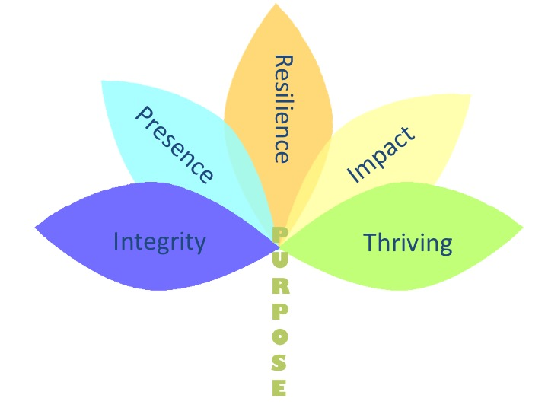
Whole Person Leadership for Women
2018

